Project Development Phase
Model Performance Test
Date | 20 September 2026
Team ID | Shaik Irshad - 238W1A4256
Project Name | Automated Network Request Management in ServiceNow
Maximum Marks
Model Performance Testing:
S.No. | Parameter | Values | Screenshot
1. | Model Summary | ServiceNow automation setup for Network Request management using a Catalog Item, Catalog Variables, a custom table (Database Tables) and Flow Designer.  Key components:  - Network Request catalog item on the Service Portal (7 catalog variables + User Information variable set with auto-population)  - Catalog UI Policy: Existing ID is visible only for an Existing connection  - Flow Designer: Service Catalog trigger → Get Catalog Variables → Create Record → Send Email → Ask for Approval → Approved / Rejected update  - Database Tables record with auto-numbered Database Number and Approval Status  - Approval Request relationship (sysapproval_approver) shown as a related list  - Default ACLs on the custom table  Note: If the submitted data is valid, the record is created and sent for approval; otherwise the form shows an error and the request is not submitted. | 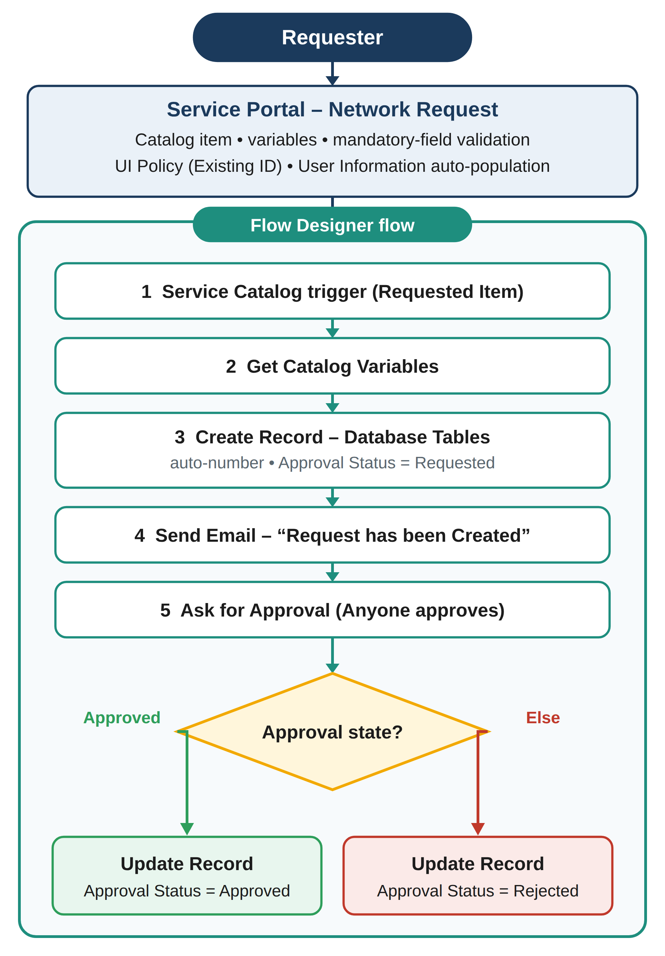  Figure 1: Network Request workflow
2. | Accuracy | Test Pass Rate - 100%  19 of 19 UAT test cases passed (0 failed)  Workflow Outcome Accuracy - 100%  Both approval paths updated the record correctly: Approved → Approval Status = Approved; Rejected → Approval Status = Rejected  Note: this project is rule-based (no ML model), so accuracy is measured as the functional test pass rate instead of training / validation accuracy. | 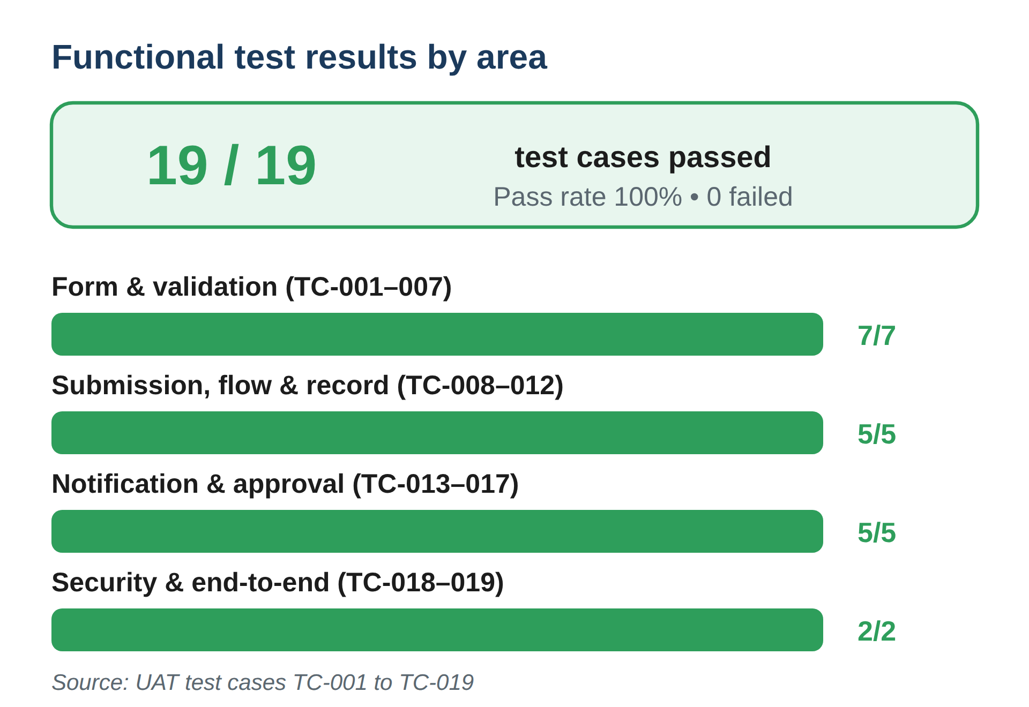  Figure 2: Test result summary (from the UAT document)
3. | Confidence Score (Only Yolo Projects)  Not applicable | Class Detected - Not applicable (no YOLO / object-detection model). Equivalent check: validation and error handling. Valid data is accepted; missing mandatory data shows an error and blocks submission.  Confidence Score - Not applicable. Outcomes are rule-based and deterministic (mandatory-field validation, UI Policy and Flow Designer conditions), so no probability score is produced. | 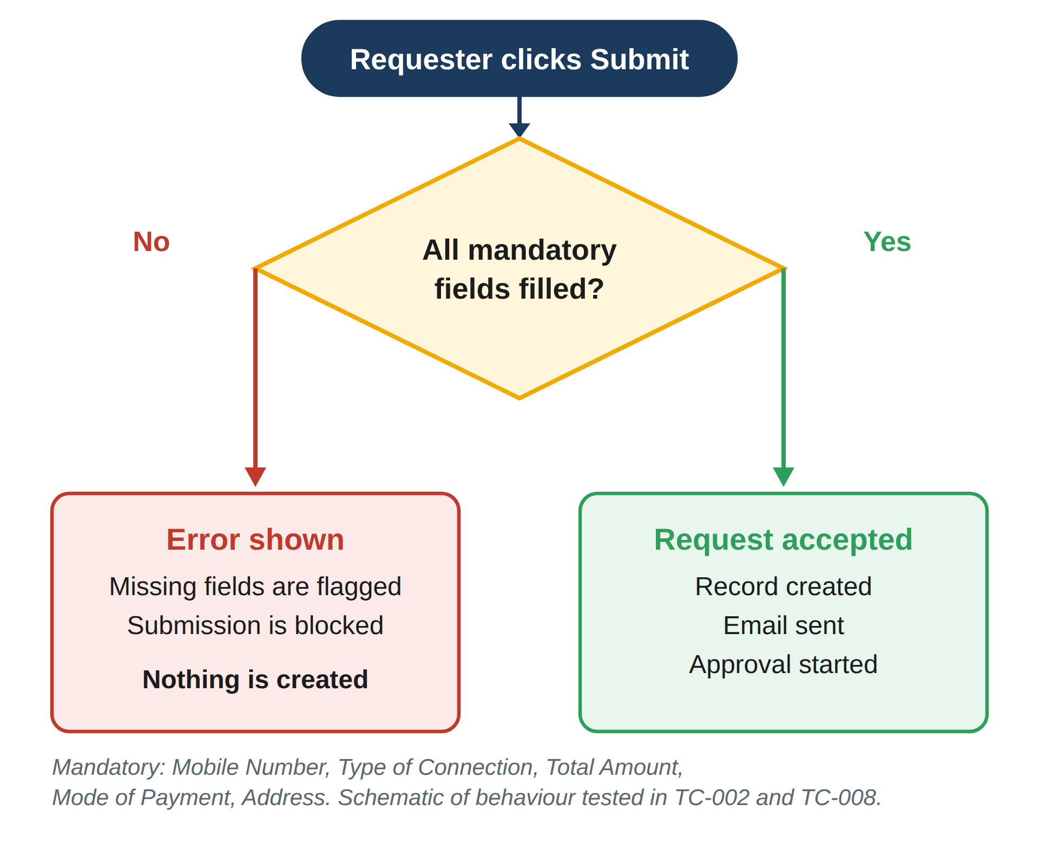  Figure 3: Validation and error handling
Figures 1 to 3 are design and result diagrams prepared for this project. Screenshots of the ServiceNow instance (Flow Execution Details, Email Logs, record and approval views) can be added to the Screenshot column as further evidence.

